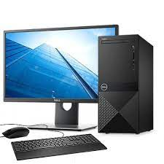

PC Dell 8th Gen

* Intel Core I5-8400
* 4GB 2400MHz DDR4L
* 1TB 7200 RPM 3.5″
* 2.80 GHz Up To 4.00 GHz
* **৳ 51,000**